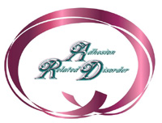
"Unsung Hero in the World of ARD!"
Certificate of Special Recognition
Presented to
Cynthia Shruhan
in recognition of outstanding and invaluable contributions in education and awareness of
"Adhesion Related Disorder."
September 17, 2005
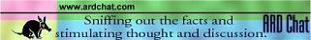
Adhesion Related Disorder Awareness Month
Because Cindy takes every opportunity to educate about ARD, she is to be recognized for her selfless devotion to persons afflicted with
"Adhesion Related Disorder (ARD)."
Cindy shares her tragic story with all so others may be spared her fate and in that, she has made a positive difference in the lives of many. Cindy finds coping skills deep with in her faith.
Her compassion for others and her example of hope, faith and courage as she faces ARD is an inspiration.
She is indeed an ARD unsung hero!
God Bless you Cindy.
Read Cindy's story along with a poignant message from her mother
Ann Marie Fritz .

